HOTEL MANAGEMENT SYSTEM
ERRORS / SUGGESTIONS
DASHBOARD :
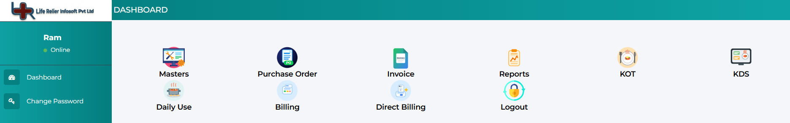
S01 : Log Out Button Problem
Placing the "Logout" icon squarely in the middle of the main working grid (right under "Reports" and next to "Direct Billing") is a massive misstep. Users moving quickly to click "Billing" or "KOT" will inevitably misclick and log themselves out during rush hours.
S02 : Redundant Navigation
There is a "Logout" icon in the main grid, but there is also a power/logout icon at the very bottom-left of the sidebar. You also have "Dashboard" in the sidebar, but the main screen is just a menu of icons rather than a true dashboard.

S03 :

E01 : "Change Password" Panel State Issue
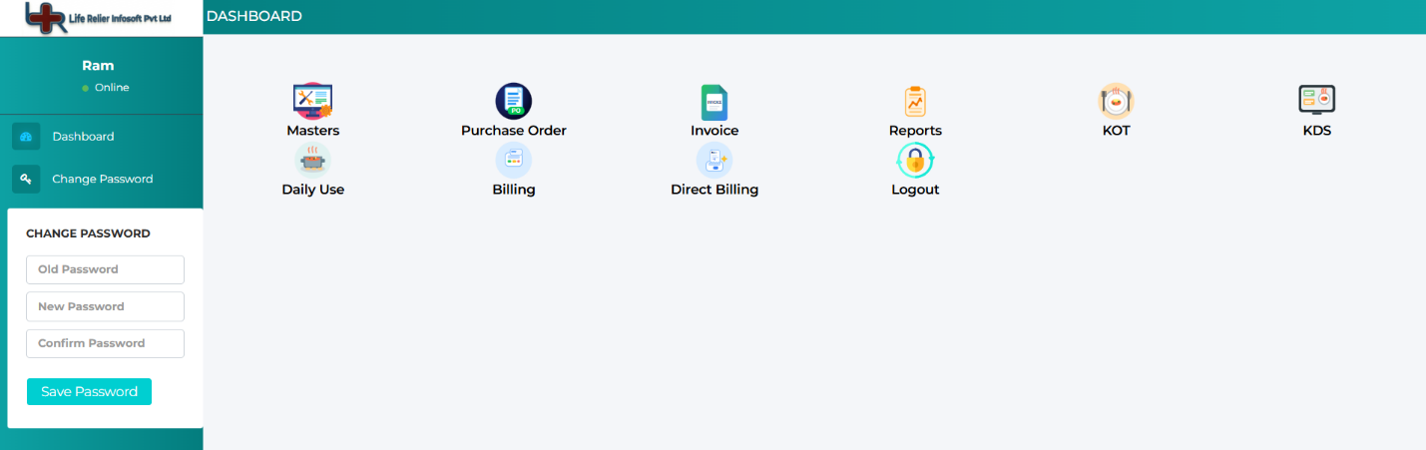
Issue: The "Change Password" panel in the sidebar gets stuck open and does not collapse when navigating away.
Steps to Reproduce:
- Click on "Change Password" in the left sidebar. (The password form expands).
- Click on "Dashboard" in the sidebar to go back.
- Notice that the password form remains open.
Expected Behavior: Clicking "Dashboard" (or any other sidebar menu item) should automatically close/hide the "Change Password" panel and reset the sidebar view.
Actual Behavior: The panel stays visible, and the user is unable to exit the "Change Password" view.
Dev Action Needed: Update the click event logic on the sidebar navigation items so that selecting "Dashboard" triggers a state change to hide the ChangePassword component/div.

KITCHEN ORDER TABLES (KOT)
S01 : Close Button Required.
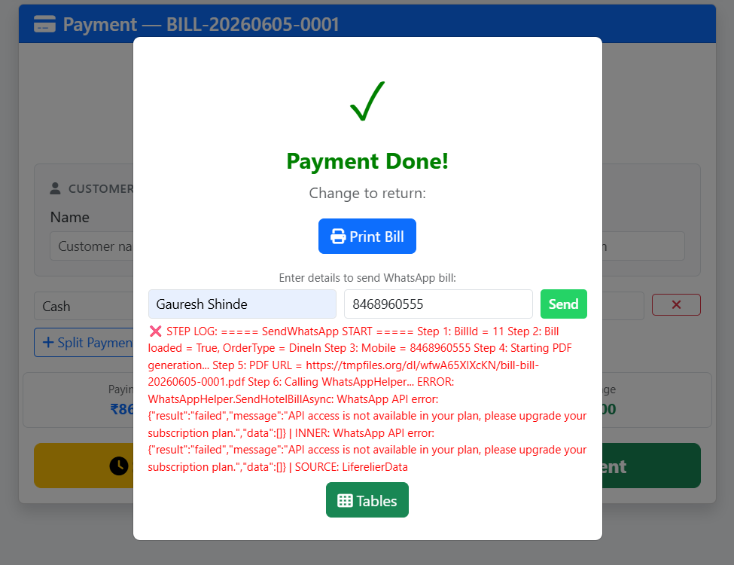
In this type of Windows there are no buttons “like Close Button” for Exit are visible.
I Think We Should Add Close Button to it.

E01 : Whatsapp Message is not getting send to customer.
Whatsapp Messages Are Not getting send via our Whatsapp

S01 : WE SHOULD PROVIDE SORT OPTION SUCH THAT USER CAN SORT DATA ACCORING TO ASCENDING OR DESCENDING ORDER OF PARTICALAR DATA.
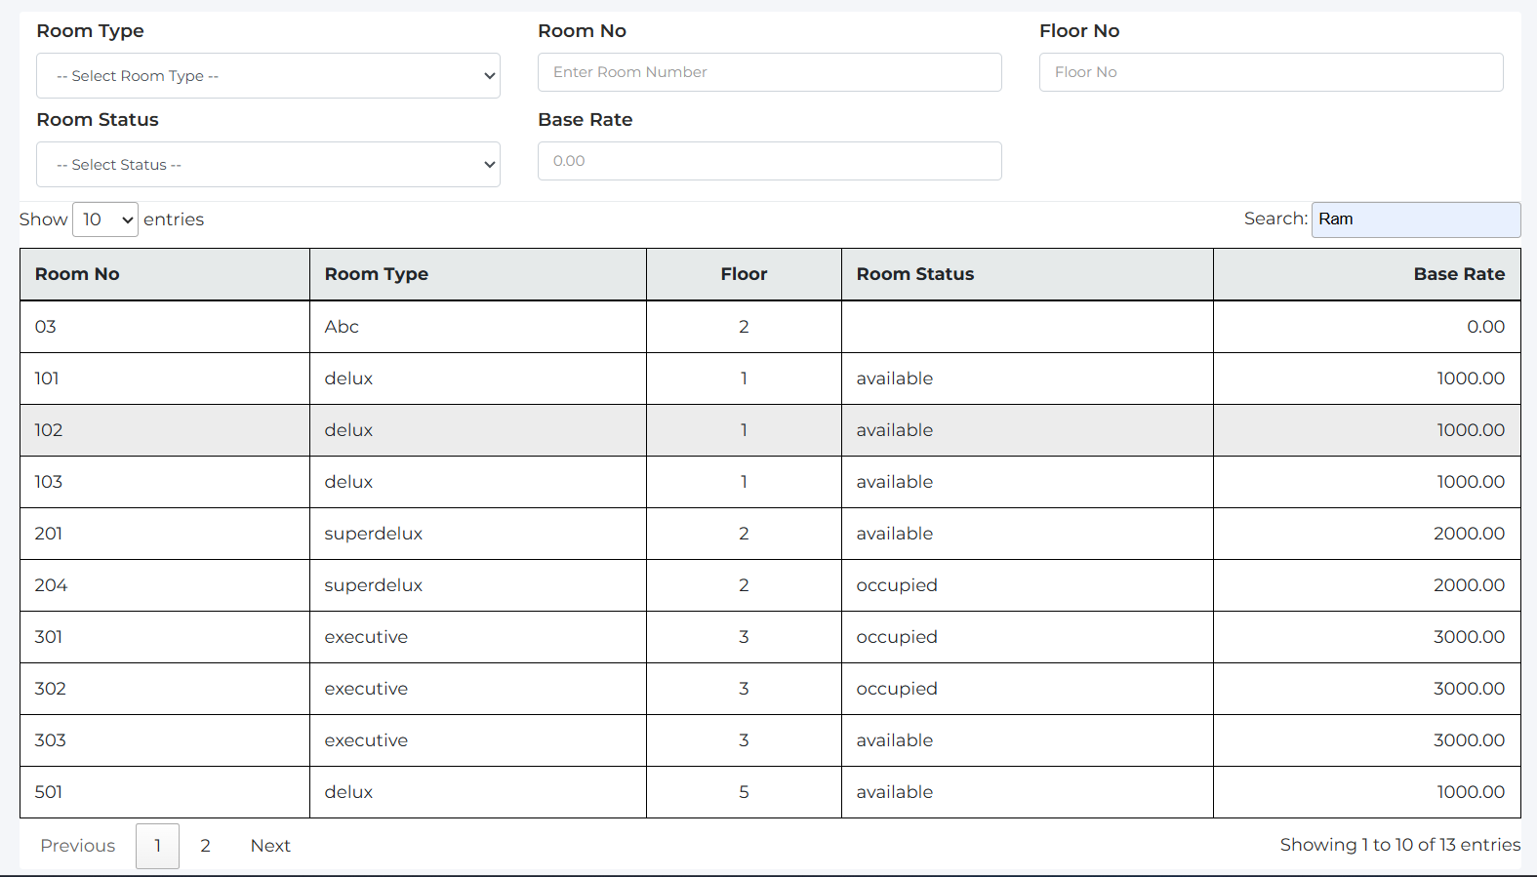
THIS IS THE WINDOW OF ROOM MASTER
PATH : MASTER -> HOTEL MANAGEMENT -> ROOM MASTER

MASTER :
MASTER -> RAW MATERIAL MANAGEMENT -> ITEM MASTER
MODULE : Item/Index
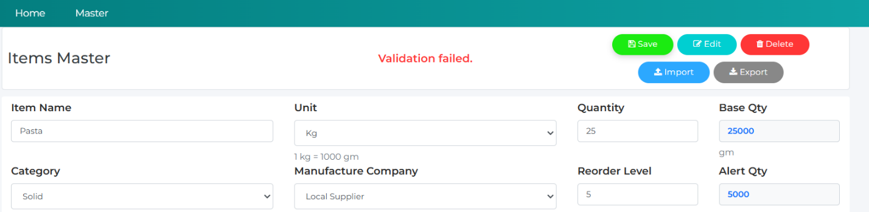
Validation is failing and that’s why Raw Material is not getting added to Stock.
2] Stock Reordering Quick Button
